A3 B/W MFP

MP 2014 MP 2014D MP 2014AD

Mono MFP

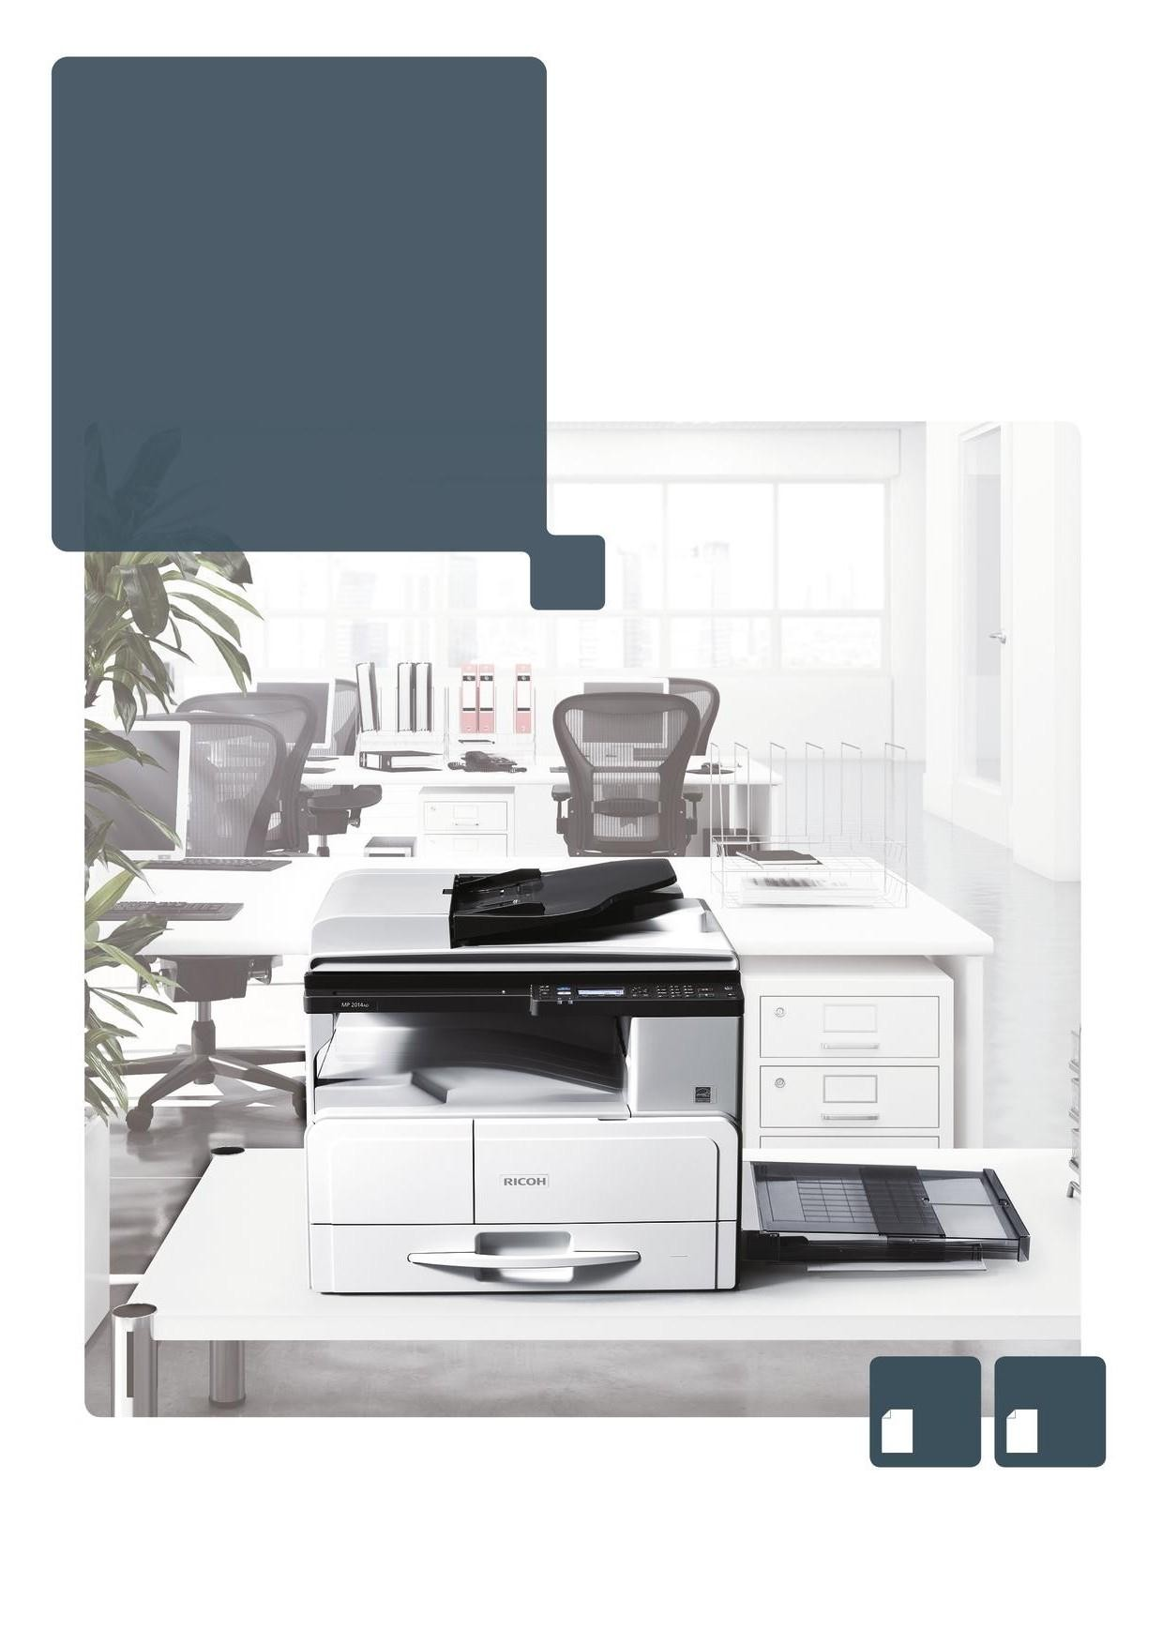MP2014AD

20 B/W
ppm
MP2014D

20 B/W
ppm

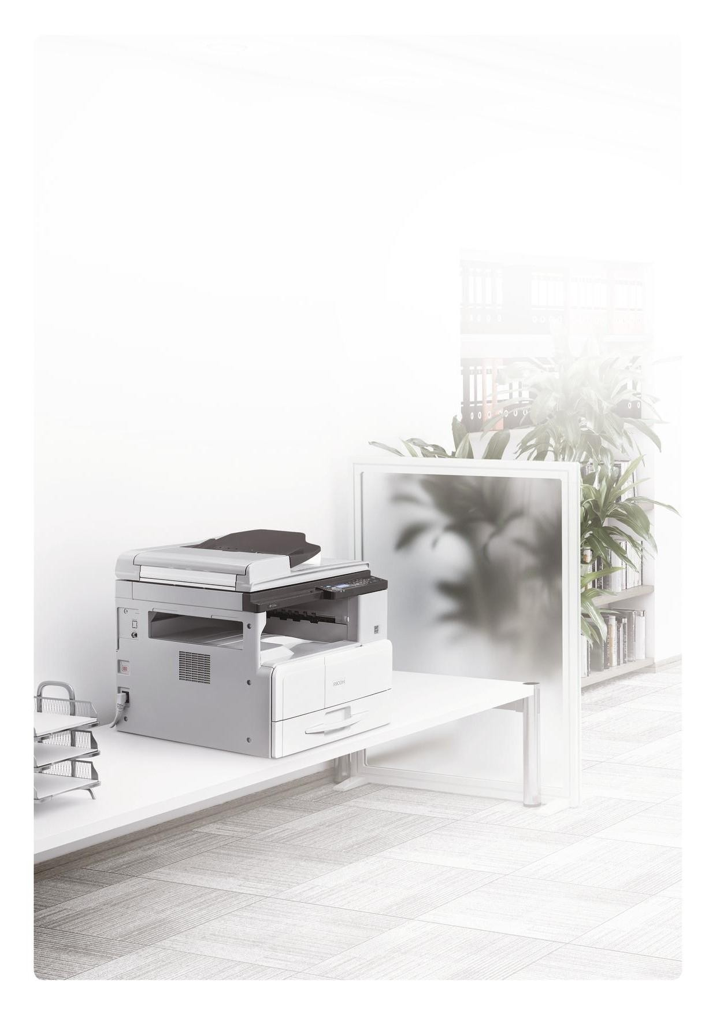Sophisticated features at an economic price

The Gestetner MP 2014 is an A3 black-and-white MFP with a brisk output speed of 20ppm, providing maximum efficiency for document processing in your office. Your total cost of ownership is low because the MP 2014 has an economical initial cost with low operating expenses. There is even an Energy Saving Key putting your MP 2014 instantly into sleep-mode, to reduce your energy bill. This reliable MFP has been designed to provide you with robust performance in demanding office environments. The benefit to you is maximum uptime ensuring professional document imaging.

ID card scan function copies both sides onto a single sheet, saving you time Customise two short-cut keys to perform frequently performed tasks quickly Automatic double-sided copying cuts your paper costs
Automatic Document Feeder on the MP 2014AD speeds up copying and scanning Economic price and low running costs make the MP 2014 a cost-effective solution

Low operating costs matched by valuable features

Low total cost of ownership

The MP 2014 offers highly competitive operating costs, saving you money. The cost of consumable sets is amongst the most economical on the market. Being able to print double-sided as standard also cuts your paper costs and reduces your carbon footprint.

Straightforward and reliable multifunctional output

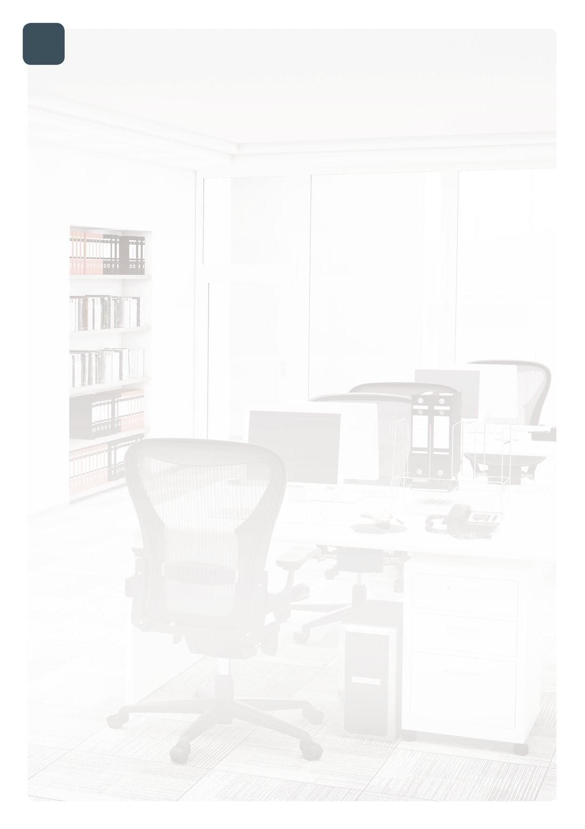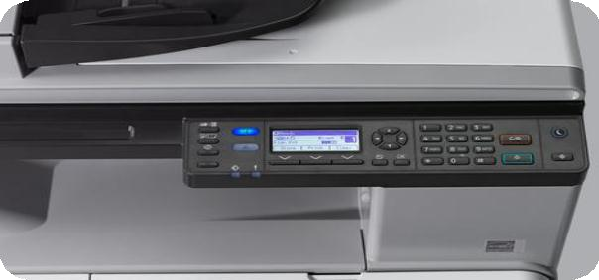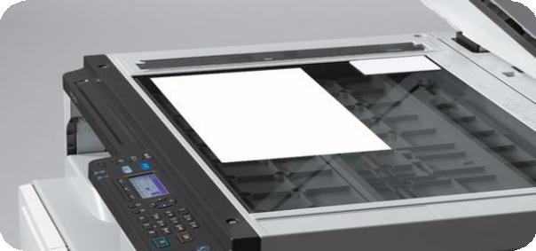

Time saving features

Highly productive features such as ID scanning simplify common copying and printing tasks for you. Short-cut keys allow one-touch customisation of frequent routines for maximum efficiency. Folder Print allows frequently used documents to be stored securely for convenient output at the touch of a button.

Full colour scanning reduces filing

Scan colour originals to your PC, email, or folder for efficient communications. Scanning at up to 600dpi resolution allows you to electronically store documents in high quality. Electronic document filing saves you storage space and reduces your paper usages.
The efficiently designed paper path means you can depend on the MP 2014 to be reliable when you need it to be. The standard USB connection is ‘plug-and-play’ meaning that you will be printing from your computer straight away. And if you need to share the MP 2014 with co-workers an optional network interface is available.

MP 2014 / MP 2014D / MP 2014AD

MAIN SPECIFICATIONS

GENERAL |  | OPTIONS
Warm-up time: First output speed: | 31 seconds  B/W: 8.8 seconds | 500-sheet paper tray, Bypass tray cover, Cabinet, Network controller

Continuous output speed:
Memory:
Dimensions (W x D x H): Weight:
B/W: 20 pages per minute
Standard: 256 MB
587 x 581 x 461/537 mm
29/33.5 kg
CONSUMABLES

Toner capacity: Black: 4,000 prints Toner cartridge (high yield): Black: 12,000 prints

Power source: 220 - 240 V, 50/60 Hz

For availability of models, options and software, please consult your

COPIER local Ricoh supplier.

Copying process: Laser beam scanning/marking & electro-photographic printing
Multiple copying: Up to 99 copies
Resolution: 300 x 600 dpi, 600 x 600 dpi
Zoom: From 50% to 200%

PRINTER

Printer language: Standard: GDI
Print resolution: GDI (600 dpi)
Interface: Standard: USB 2.0 Option: Ethernet
Network protocol: Option (TCP/IP)

SCANNER

Scanning speed: 200 dpi: Full colour (A4), B/W (A4)
Resolution: Standard: - 600 dpi
File format: Single page TIFF, Single page JPEG, Single page PDF, Multi page TIFF, Multi page PDF
Bundled drivers: Network TWAIN
Scan to (Option): E-mail (Requirement), Folder (Protocol support)

PAPER HANDLING

Recommended paper size: Standard paper tray(s): A3, A4, A5, B4, B5
Bypass tray: A3, A4, A5, A6, B4, B5, B6
Paper input capacity: Standard: 350 sheets Maximum: 1,350 sheets
Paper output capacity: Standard: 250 sheets
Paper weight: Paper tray(s): 52 - 105 g/m² Bypass tray: 52 - 216 g/m²
Duplex: 64 - 105 g/m²
ADF: 64 - 128 g/m²

ECOLOGY

Power consumption: Maximum: Less than 950W Ready mode: 100/110 W
Low power mode: 48.3/47.8 W
Sleep mode: Power (2.8 W), Recovery (20 sec.)
TEC (Typical Electricity Consumption): 1.5/1.52 kWh

ISO9001 certified, ISO14001 certified, ISO27001 certified
All brand and/or product names are trademarks of their respective owners.
Specifications and external appearance are subject to change without notice. The colour of the actual product may vary from the colour shown in the brochure. The images in this brochure are not real photographs and slight differences in detail might appear.
Copyright © 2015 Gestetner Europe PLC. All rights reserved. This brochure, its contents and/or layout may not be modified and/or adapted, copied in part or in whole and/or incorporated into other works without the prior written permission of Gestetner Europe PLC.

